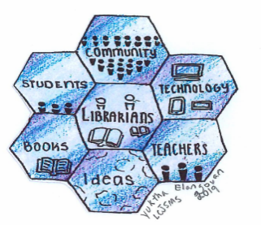
New Jersey Association of School Librarians Annual Fall Conference December 9 – 10, 2019 Hilton East Brunswick Hotel and Meeting Center East Brunswick, NJ
NJASL 2019 “Better Together”
Dear Exhibitor,
It is a pleasure to extend to you this invitation to reserve your spot at the New Jersey Association of School Librarians Annual Fall Conference. Each year we invite vendors to display their products for New Jersey’s school library media specialists, public librarians, administrators, and educators. If you have attended our conferences in the past, you know that all the attendees leave our gathering informed, enlightened and enthused. YOU are a very important part of our plan to highlight our theme “Better Together”
Our conference will be held at the Hilton East Brunswick Hotel & Meeting Center on December 9 & 10, 2018. We are still in the beginning stages of planning various activities but we have a designated time just to visit the Vendors! Vendor Bingo (which was popular in the past), extended lunch time in the Hall, Raffle drawings, Concession breakfasts, lunches and Coffee/Tea plus other activities that we hope will have your area busy with the approximate 500 attendees! A Preliminary Schedule has been included in this email and a more detailed schedule will be sent in the Fall.
As of now, we are considering having each Rep register online as we did last year. It helped our Registration people and we were able to have badges and packets ready. Each Rep from your company will be receiving an invitation to register and someone (either me or our Registrar) will be available to help. Final decision and information on this will be forthcoming in the Fall.
We encourage you to be part of our conference and invite you to have our attendees learn about your company’s products and services by setting up an exhibit, sponsoring an event, advertising in our program, and donating an item to the raffles. We are anticipating many new vendors this year. Spaces are assigned on a first-received basis as well as sponsorship status. Our spaces are usually sold out, so we urge you to register early by returning the enclosed application, and the application Certification plus payment to:
Leslie Blatt c/o NJASL PO Box 1460 Springfield, NJ 07081
Please make checks payable to: New Jersey Association of School Librarians [NJASL]
Deadline: October 26, 2019 (to ensure placement in program book)
I am looking forward to working with you. Please email me with any questions you may have.
Sincerely,
Leslie Blatt, Exhibits Chair 973-951-4152 (cell) MrsLes@aol.com
Enc: Exhibit Space application, Certification, Regulations, Sponsorship opportunities, Proposal form

