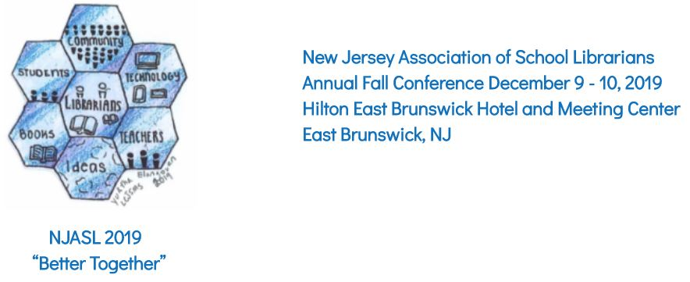
Please email your proposal no later than July 31, 2019 to Leslie Blatt at ​mrsles@aol.com​. Add any additional comments in your email.

PERSON SUBMITTING PROPOSAL:
Name:
School (include District) or Organization:
Position and/or Title:
Telephone Day:
Night:
Email:
NJASL Member:  NJLA Member:  NJAET Member: | ❑ Yes​ ❑ No​  ❑ Yes​ ❑ No​  ❑ Yes​ ❑ No​
CO-PRESENTER(S):
Name:
School (include District) or Organization:
Position and/or Title:
Telephone: Day:
Night:
Email:
NJASL Member:  NJLA Member:  NJAET Member: | ❑ Yes​ ❑ No​  ❑ Yes​ ❑ No​  ❑ Yes​ ❑ No​

There will be three different session types this year:
- Concurrent Session (6o minutes) - traditional NJASL session format
- *NEW Spark and Tell Session (10 minute presentation) - 5 presentations at 10 minutes each to be followed by a Q&A session
You will need to provide NJASL with your slides beforehand so they can be pre-loaded with the other Spark & Tell sessions. You will need to be prepared to start your presentation when your slideshow begins. A moderator will take 5 minutes to explain to the audience how this session format will run in the beginning of the session, and then they will start a group slideshow. 5 Spark & Tell sessions will run back-to-back, and there will be 5 minutes at the end of the presentations for Q&A for all presenters. Please be courteous to the other Spark & Tell presenters and do not go over your allotted 10-minutes for your session. If you are the next presenter, please be up front and ready to start your presentation.

3. *NEW Speed Learning Session (15 minute presentations)
In the ballroom - divided into three 15-minute segments. Each speed learning session is assigned to a roundtable that holds 8-10 participants (please keep this in mind if you have co-presenters as it will limit the number of participants for your table). There will be (3) session rotations within 60 minutes, so you present the same 15-minute session three times in a row, each time to a different audience. Participants will have an additional (5) minutes to move to their next table selection between session times. A moderator will signal the participants and presenters when each session begins and ends.

PROPOSED PROGRAM INFORMATION:

Session type:
- Concurrent
- Spark and Tell
- Speed Learning

- Program Title exactly as it should appear in program (10 word limit):

- Program Description: Describe your session in 50 words or fewer (this will appear in the conference program). What will others learn from you and how might they use it in their practice?

- Intended Grade Levels:
❑ Elementary ❑ Middle ❑ High ❑ Higher Ed ❑ All ​ ​ ❑ Other ________

- Select any strands as labels for your session.
❑ Instruction ❑ Professional Growth
❑ Media Literacy/Digital Citizenship ❑ Literature/Book Talk
❑ Makerspace ❑ STEM
❑ Technology ❑ Community Engagement
❑ Author/Illustrator ❑ Vendor

BYOD:​ Should this session be labeled as BYOD (Bring Your Own Device)?
​ ​❑ Yes​ ❑ No​

SPECIFICATIONS:​ (We will try to accommodate your needs as the schedule permits.)
Preferred Day/Days to Present: ❑ Monday, 12/9 ❑ Tuesday 12/10

Would you consider presenting twice? ❑Yes ❑ No

If Yes: ❑ Same Day ❑ Two Days

INTERNET ACCESS:​ Does your presentation require Internet access? ❑ Yes ❑ No

AUDIO VISUAL EQUIPMENT: Each workshop room will be equipped with a screen and projector and​ table or podium. Presenters must bring all other equipment. ​Please note that if you will be using an Apple computer or a computer that needs an adapter, you will need to bring that adapter for use with your projection equipment. NJASL will NOT provide adapters. Wireless Internet access will be available in each room, but it can take some time to​ access. Please arrive at least 15 minutes prior to your session time for set-up.

ROOM SET-UP: Break-out rooms are set up with chairs for participants.
Do you require tables to​ be set up for this session? ​❑ Yes, tables are needed
Other set-up needs? Please explain:

Additional Notes:
Session Resources: NJASL​ will be setting up a Sched account where presenters will be able to upload or supply links to their session resources for our members and attendees access. We will supply presenters with access information upon acceptance.

Photo/Video Release: NJASL​ will be videotaping many sessions at this year’s conference. Session presenters will be required to sign a photo and video waiver/release upon acceptance.

Acknowledgement of this proposal will be made via e-mail and will constitute your adherence to the information provided in this document. Thank you.

All proposal forms and questions should be e-mailed to Leslie Blatt at mrsles@aol.com by July​ 31, 2019

We look forward to seeing you at Hilton East Brunswick. Thank you for submitting.

Beth Thomas, 2019
Conference Chair njasl19@njasl.org

